|  |  |
| --- | --- |
| Team ID | PNT2022TMID40995 |
| Project Name | Plasma Donor Application |

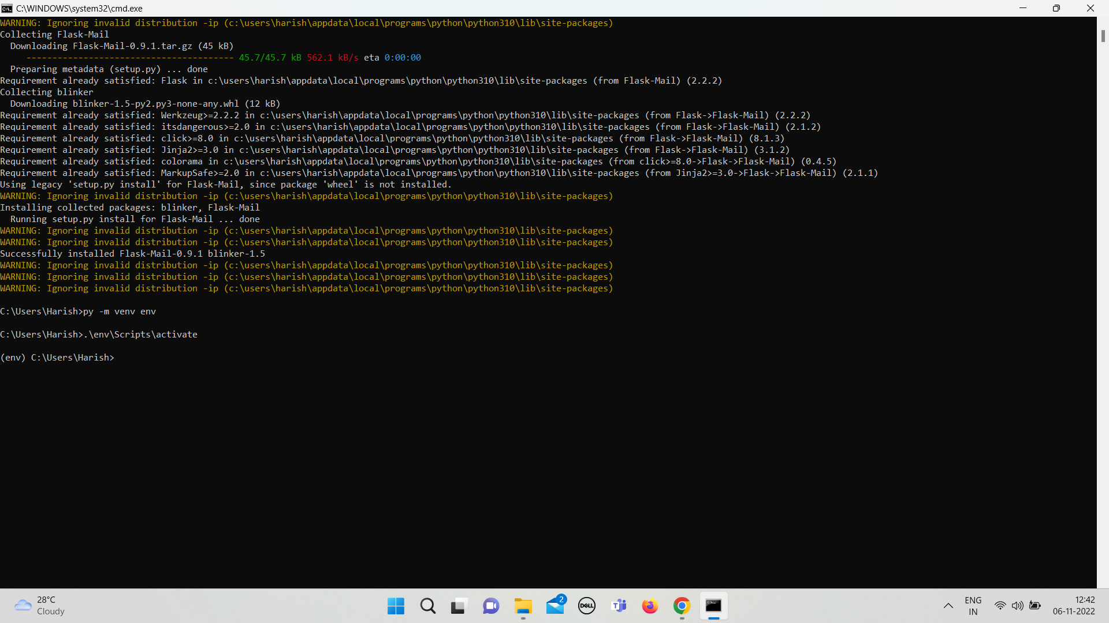 **Creating Flask mail API**

Creating FLASK-MAIL instead of creating account in sendgrid .